It may be desirable to create a relational schema from an XML document that doesn’t conform to an XML schema. Much work has been directed towards XML schema inference from an XML document and applications have even been implemented. The challenge would be ensuring that all XML Schema constructs could be parsed successfully. This would require considering the whole XML Schema grammar as described in Appendix I.
Bibliography
Papers

Ref | Title | Source
[1] | Storing and Querying XML Data using an RDBMS | ACM SIGMOD international conference on Management of data (2002)
[2] | A General Technique for Querying XML Documents using a Relational Database System | ACM SIGMOD Record Volume 30 Issue 3 (September 2001)
[3] | Representing the XPath model in Relational Databases
[4] | Schema Conversion Methods between XML and Relational Models | Knowledge Transformation for the Semantic Web (2003)
[5] | CPI: Constraints-Preserving Inlining Algorithm for Mapping XML DTD to Relational Schema | Journal of Data & Knowledge Engineering 39 (2001)
[6] | XER - Extensible Entity Relationship Modeling | XML Conference and Exposition (December 2003)
[7] | Conceptual Modeling of XML Schemas | ACM international workshop on Web information and data management (2003)

Books
Title | Author | Publisher
XML Processing in Java | Elliotte Rusty Harold | Addison-Wesley Professional
Practical Postgresql | John C. Worsley, Joshua D. Drake | O'Reilly & Associates
SQL in 10 minutes | Teach Yourself SQL in 10 Minutes | Sams
Essential XML Quick Reference: A Programmer's Reference to XML, XPath, XSLT, XML Schema, SOAP, and More |  | Addison-Wesley Professional

APIs

Name | Homepage
JDOM | http://www.jdom.org/
XML Schema Infoset Model | http://www.eclipse.org/xsd/
JGraphT | http://jgrapht.sourceforge.net

Manuals

Name | Source
PostgreSQL online manual | http://www.postgresql.com/docs/7.3/static/index.html

Websites

Name | Address
World Wide Web Consortium (W3C) XML Schema | http://www.w3.org/XML/Schema
XML Schema structures | http://www.w3.org/TR/2004/PER-xmlschema-1-20040318/
W3 Schools XML Schema Tutorial | http://www.w3schools.com/schema/default.asp
Apache XML Project (Xindice) | http://xml.apache.org/xindice/faq.html#faq-N1002B
XML Schema languages | http://www.cobase.cs.ucla.edu/tech-docs/dongwon/ucla-200008.html

Appendix I
XML Schema grammar
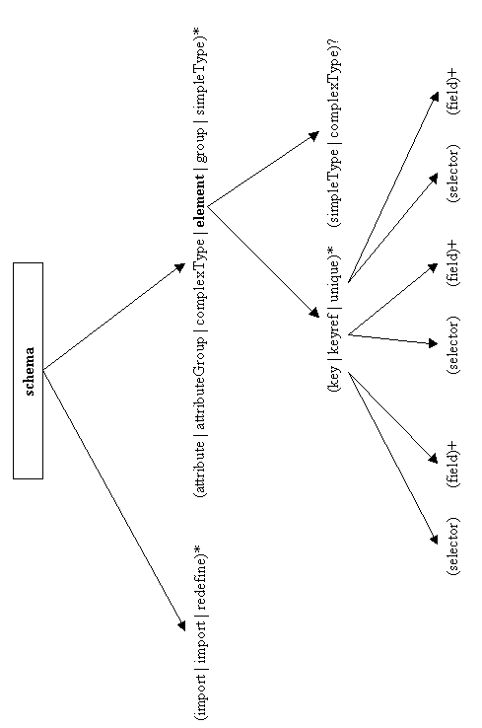

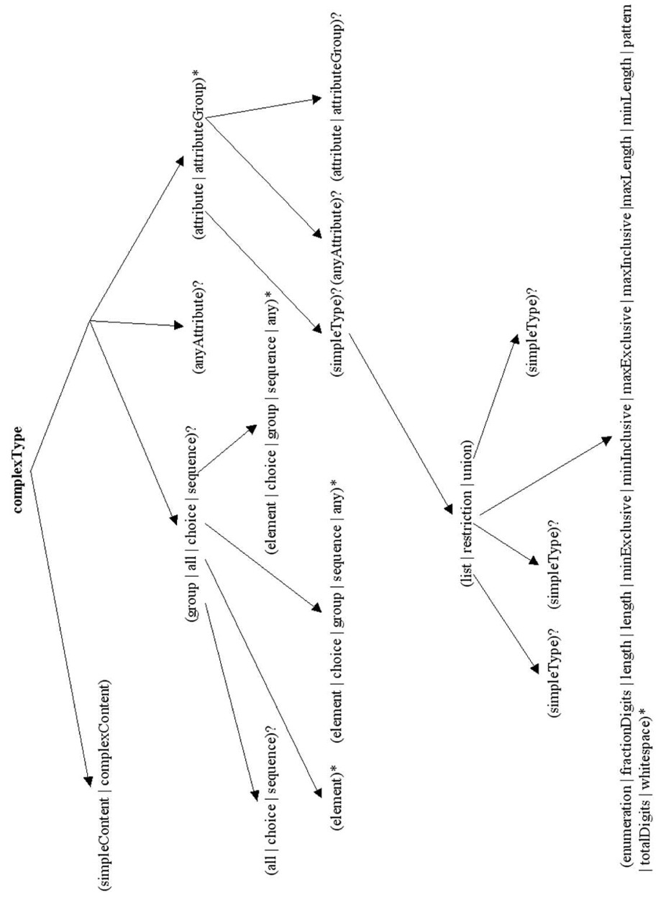

Annotation has been omitted from the tree, but can appear as a child of any construct
Appendix II
Catalog tables

catalog_elements
element | parent_element | alias | type | unordered
ps_db |  |  | complex | false
supplies | supplier |  | simple | false
sup | name |  | simple | false
part | ps_db |  | complex | false
name | supplier |  | mixed | false
supplier | ps_db | manufacturer | complex | false

catalog_attributes
attribute | element | alias
sno | supplier | manufacturer_number
town | supplier
colour | part
pno | part
price | part

catalog_specialzations
specialization | generalization
sup | name_choice
supplier | ps_db_choice
part | ps_db_choice

catalog_generalizations
generalization | alias
ps_db_choice
name_choice

catalog_ids_to_tables
id | table
1 | ps_db
2 | part
3 | part
4 | part
5 | supplier
6 | name
7 | supplies
8 | supplies

Resources
The project homepage can be found at:

http://www.doc.ic.ac.uk/~ss401/project

Here you will find:
- Compiled Application (latest version)
- Source code
- Javadoc
- This report

These may also be found on the enclosed CD.

